**Examining scoring outcomes with variable shot selection strategies in Super Netball’s ‘Power 5’ period via numerical simulation**

***Supplementary Material 1***

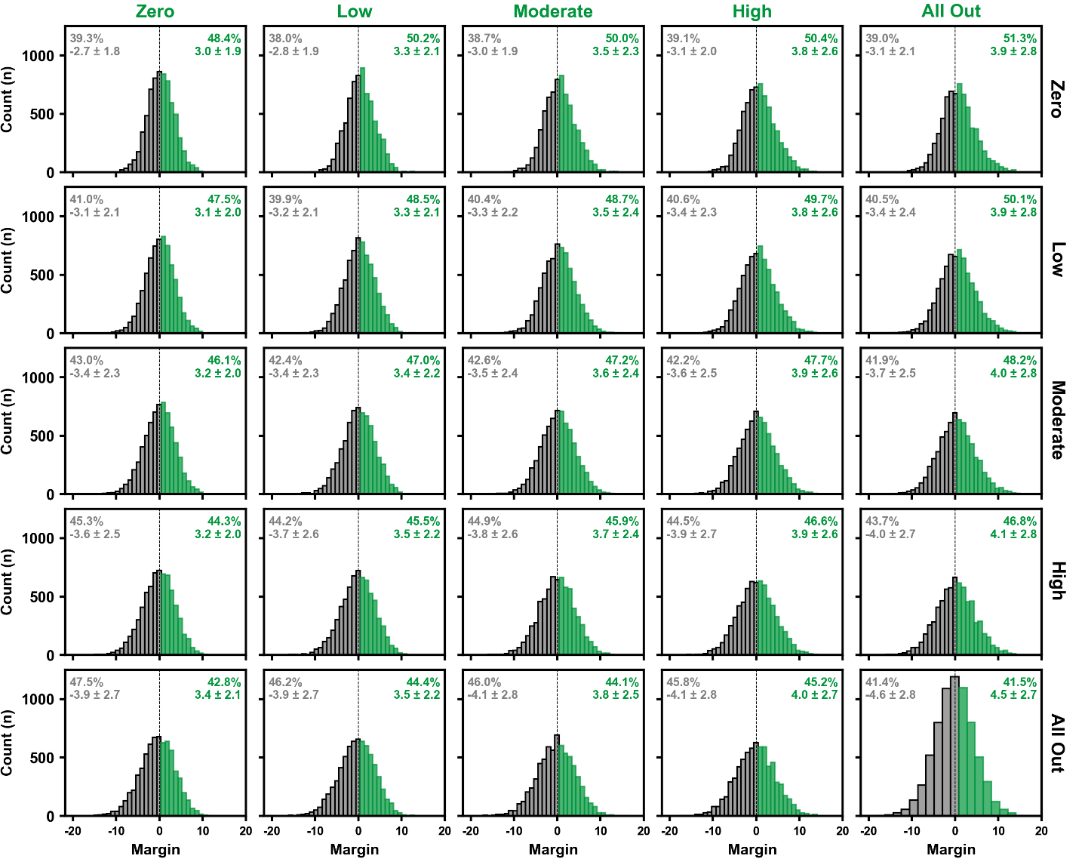

*Figure S1. Power 5 margin distribution for simulations including the Fever against all other opponents using different Super Shot selection strategies. The Fever’s strategy is indicated by the column labels and their opponents by the row labels. The frequencies, mean (± standard deviation) margin, and proportion of simulations won and lost by the Fever is indicated by coloured versus greyed data, respectively.*

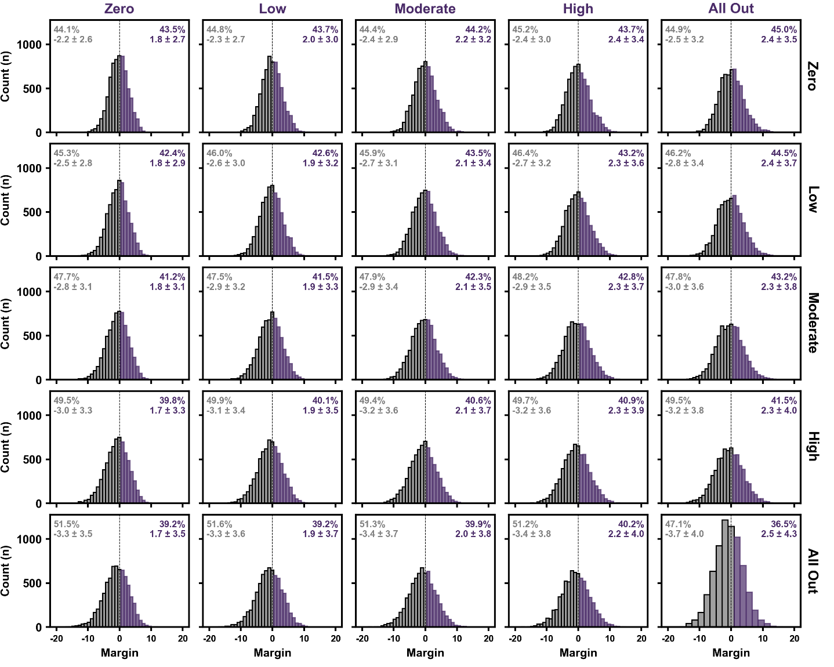

*Figure S2. Power 5 margin distribution for simulations including the Firebirds against all other opponents using different Super Shot selection strategies. The Firebirds strategy is indicated by the column labels and their opponents by the row labels. The frequencies, mean (± standard deviation) margin, and proportion of simulations won and lost by the Firebirds is indicated by coloured versus greyed data, respectively.*

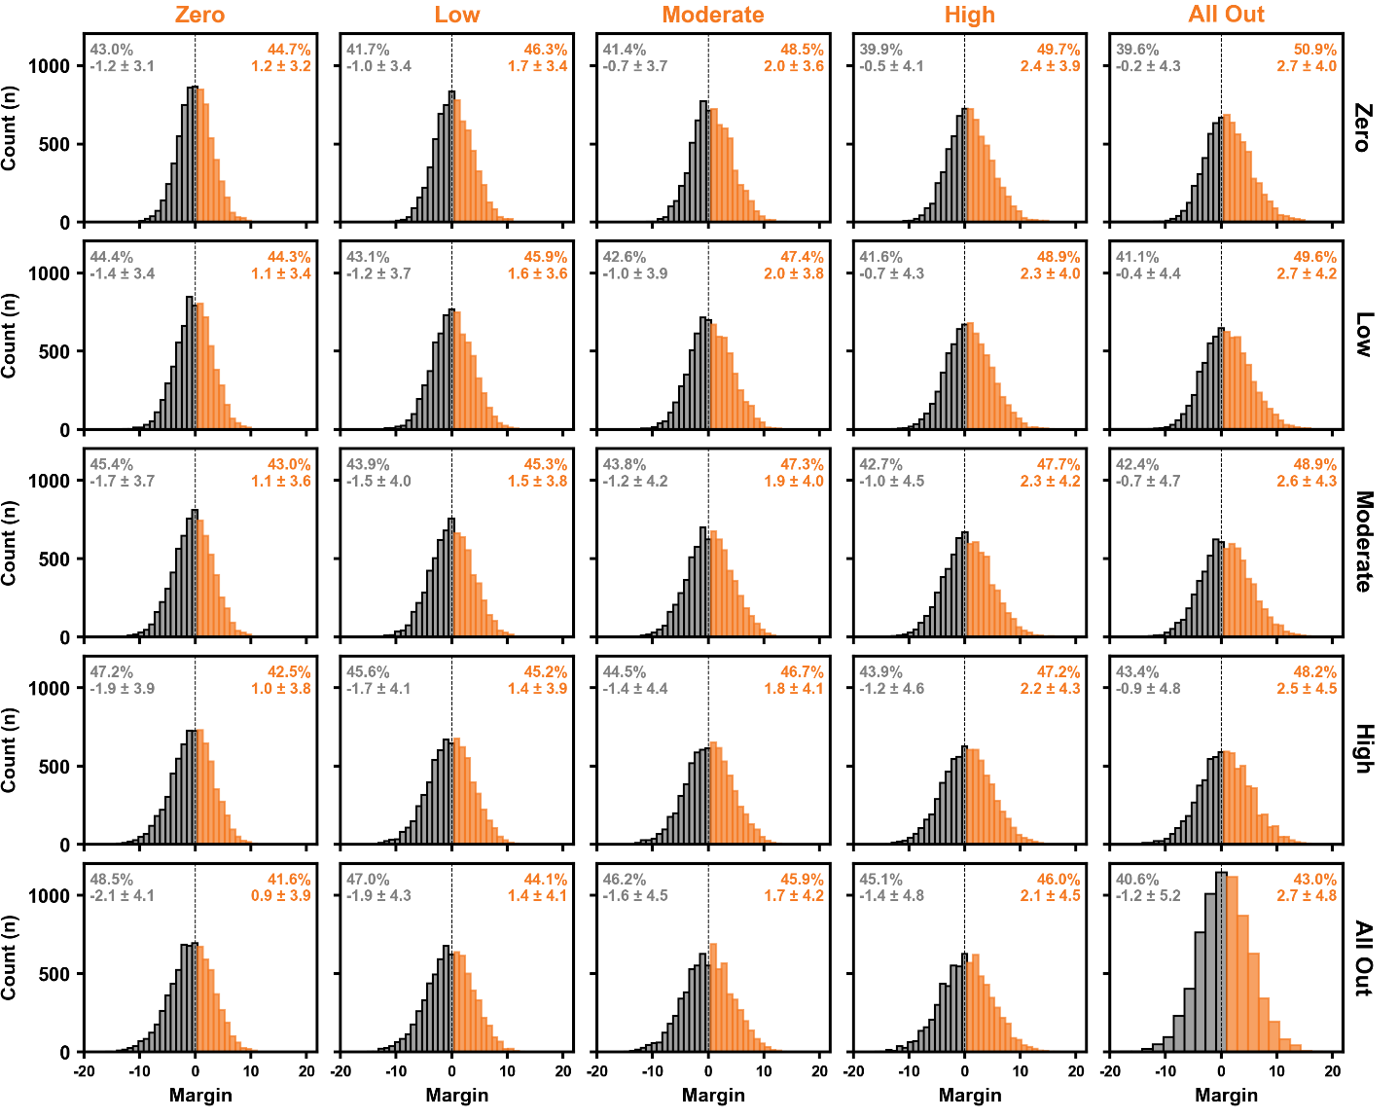

*Figure S3. Power 5 margin distribution for simulations including the Giants against all other opponents using different Super Shot selection strategies. The Giants strategy is indicated by the column labels and their opponents by the row labels. The frequencies, mean (± standard deviation) margin, and proportion of simulations won and lost by the Giants is indicated by coloured versus greyed data, respectively.*

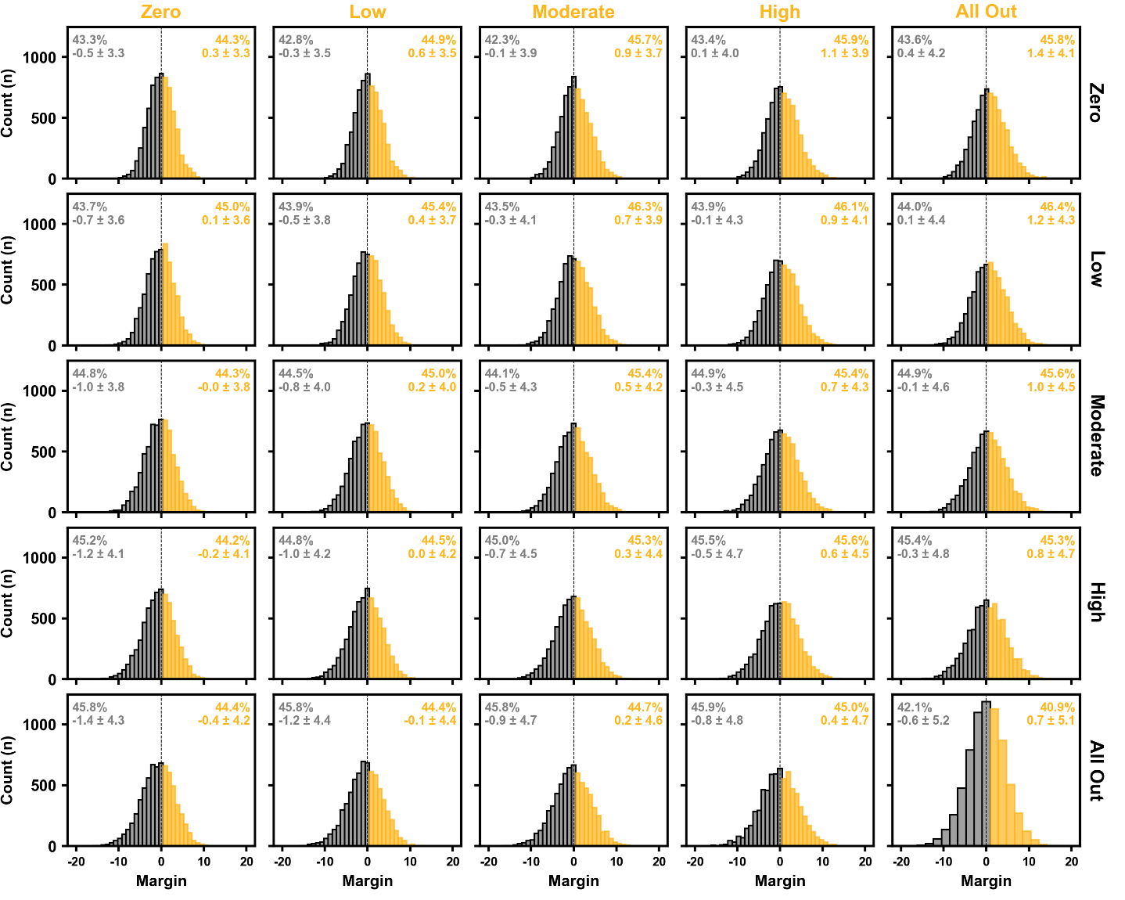

*Figure S4. Power 5 margin distribution for simulations including the Lightning against all other opponents using different Super Shot selection strategies. The Lightning’s strategy is indicated by the column labels and their opponents by the row labels. The frequencies, mean (± standard deviation) margin, and proportion of simulations won and lost by the Lightning is indicated by coloured versus greyed data, respectively.*

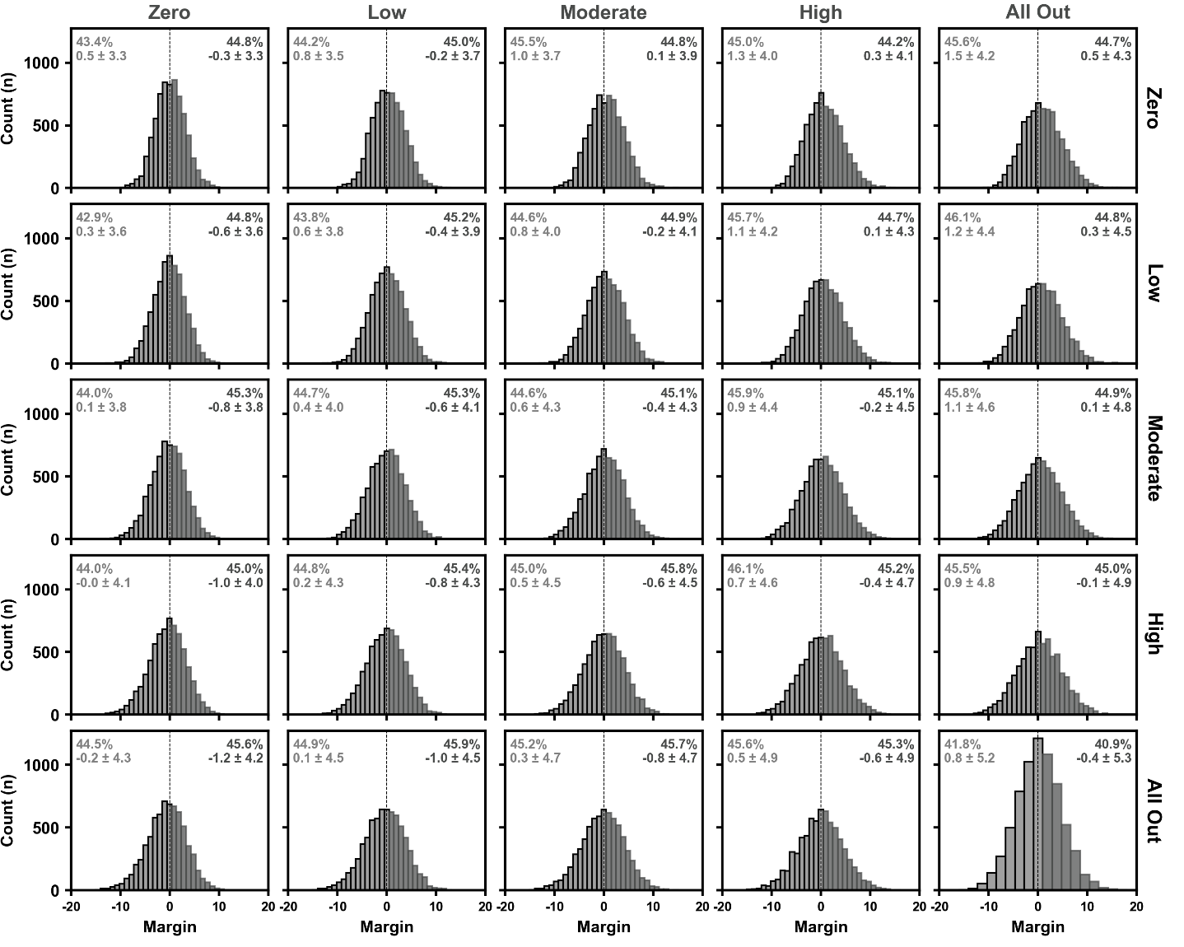

*Figure S5. Power 5 margin distribution for simulations including the Magpies against all other opponents using different Super Shot selection strategies. The Magpies strategy is indicated by the column labels and their opponents by the row labels. The frequencies, mean (± standard deviation) margin, and proportion of simulations won and lost by the Magpies is indicated by coloured versus greyed data, respectively.*

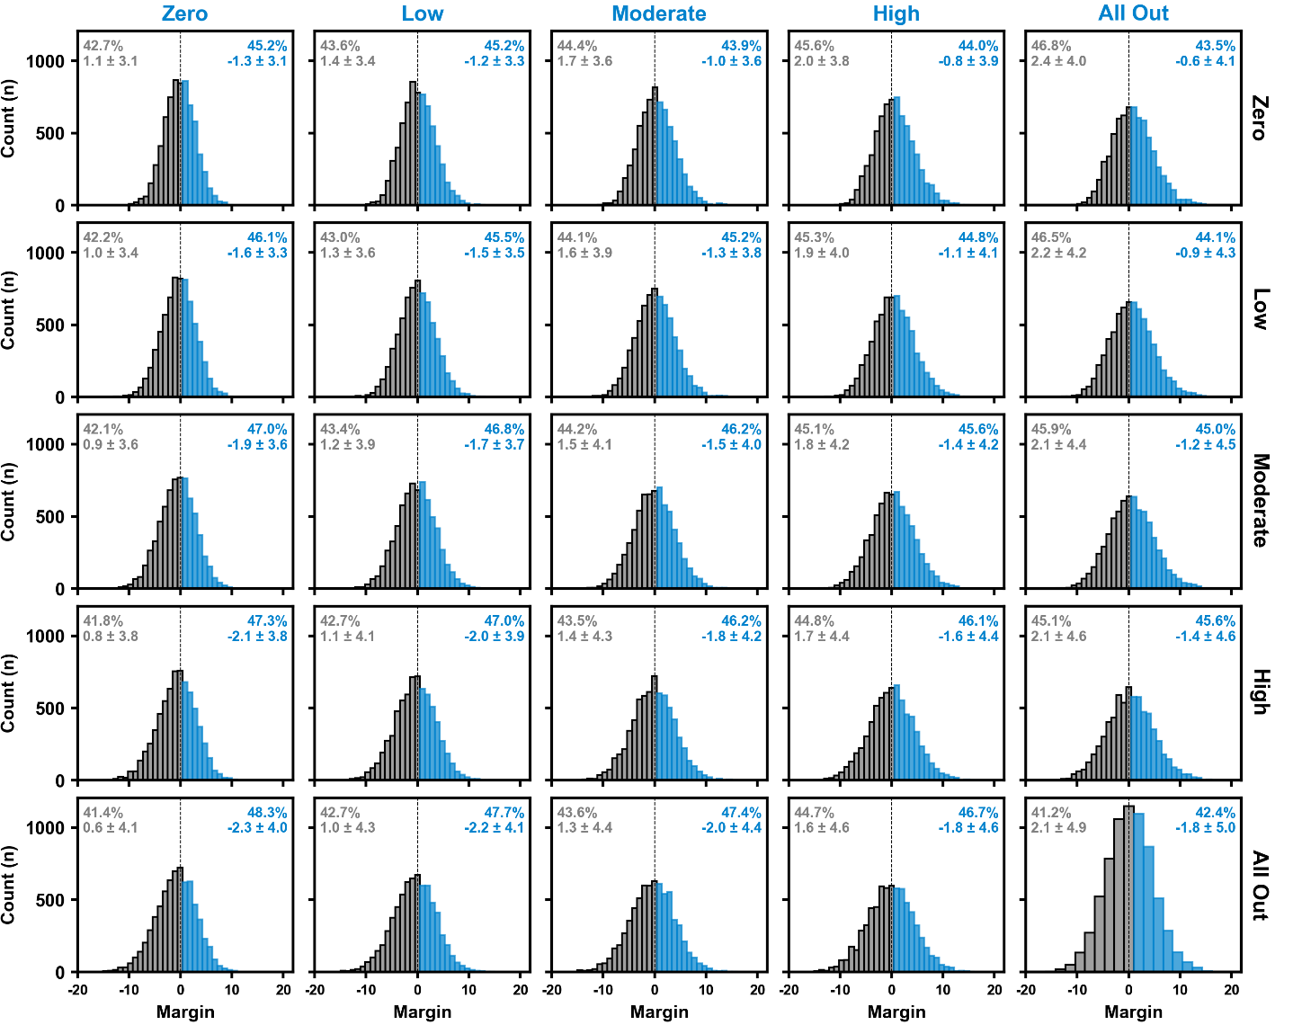

*Figure S6. Power 5 margin distribution for simulations including the Swifts against all other opponents using different Super Shot selection strategies. The Swifts strategy is indicated by the column labels and their opponents by the row labels. The frequencies, mean (± standard deviation) margin, and proportion of simulations won and lost by the Swifts is indicated by coloured versus greyed data, respectively.*

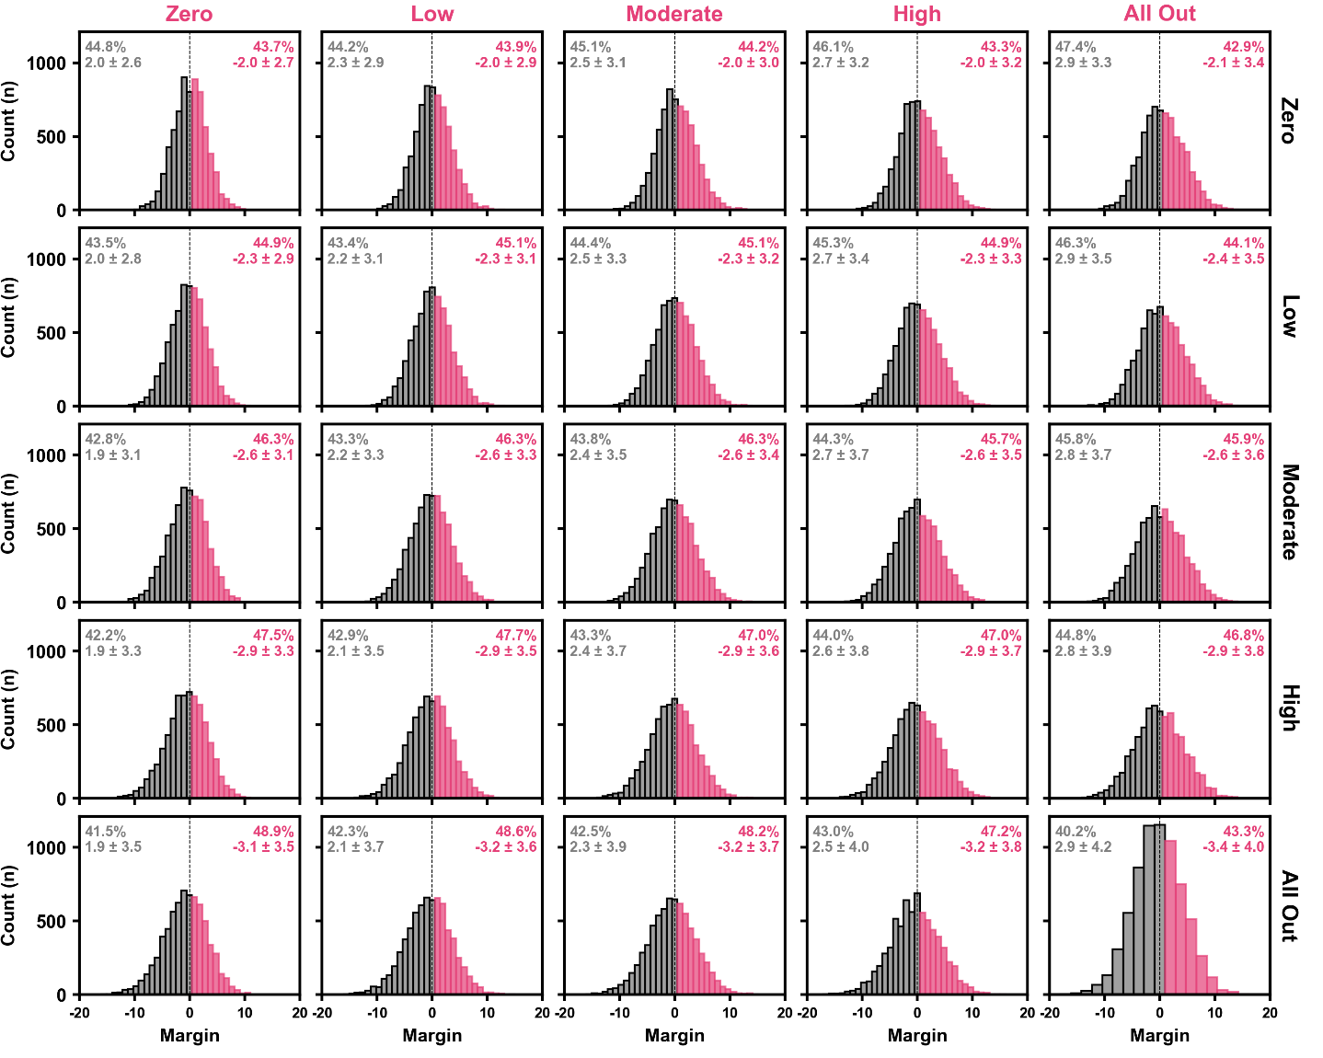

*Figure S7. Power 5 margin distribution for simulations including the Thunderbirds against all other opponents using different Super Shot selection strategies. The Thunderbirds strategy is indicated by the column labels and their opponents by the row labels. The frequencies, mean (± standard deviation) margin, and proportion of simulations won and lost by the Thunderbirds is indicated by coloured versus greyed data, respectively.*

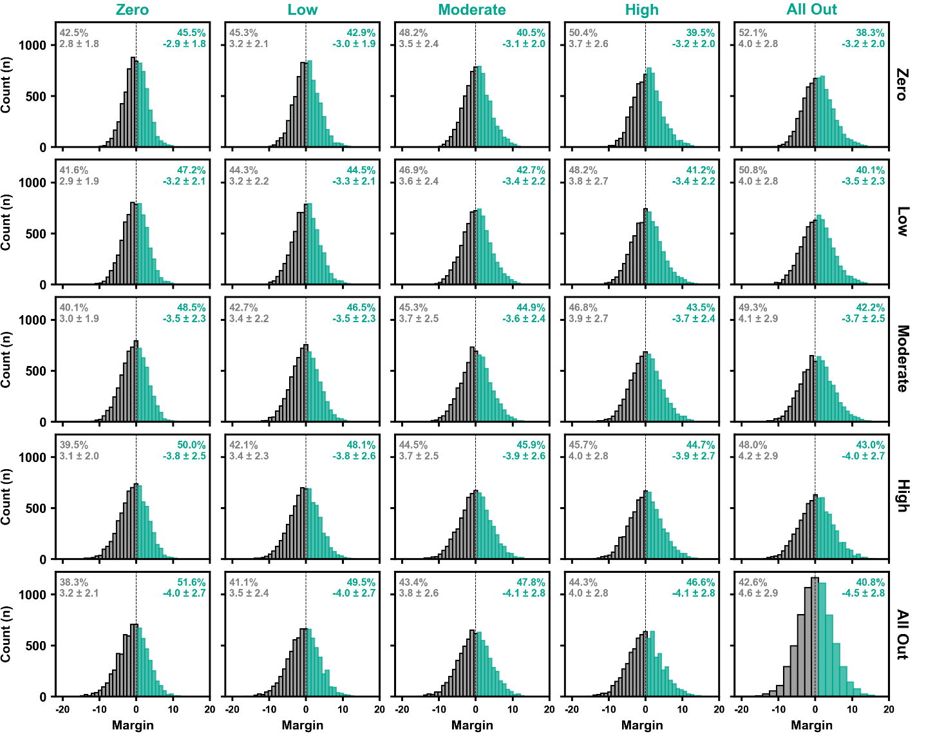

*Figure S8. Power 5 margin distribution for simulations including the Vixens against all other opponents using different Super Shot selection strategies. The Vixens strategy is indicated by the column labels and their opponents by the row labels. The frequencies, mean (± standard deviation) margin, and proportion of simulations won and lost by the Vixens is indicated by coloured versus greyed data, respectively.*